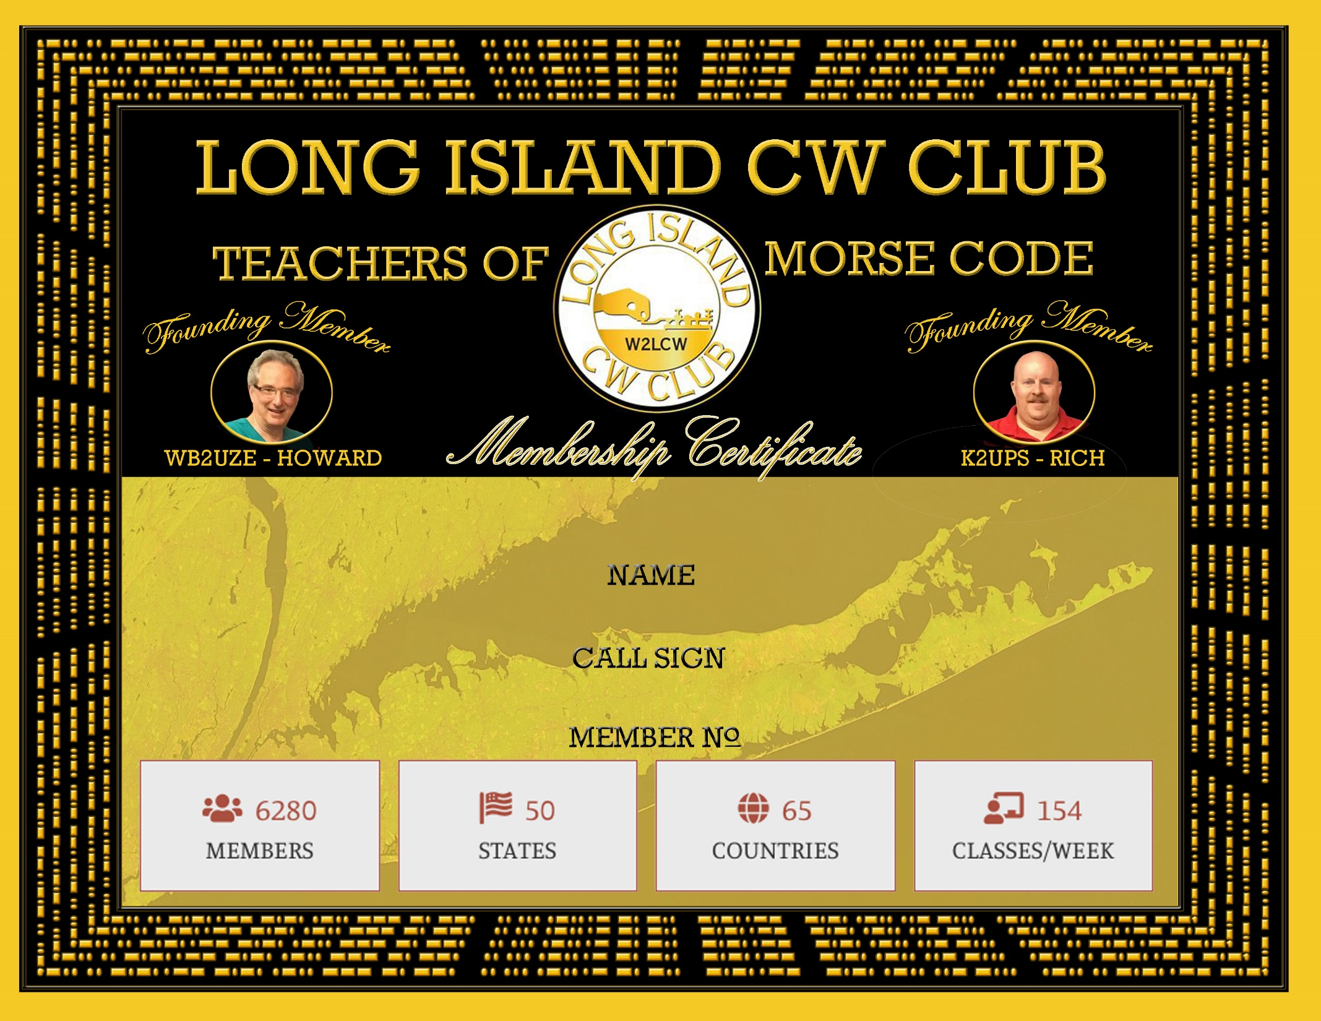YOUR NAME HERE

KL0CK

7065