t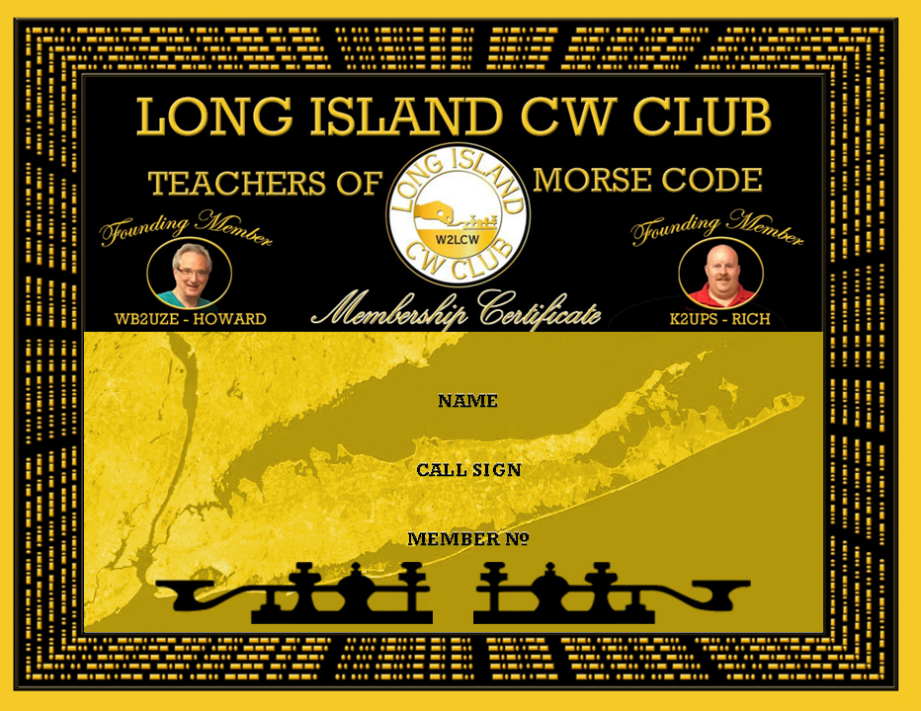
Russell Calabrese
KR2NZ
1705

